1) (a)
i. (x = 50) very cool; not warm; not hot at all

ii. (x=90) not cool at all; kind of warm; fairly hot

iii. kind of cool; rather warm; kind of hot

(b) (y = 50%) not really dry; very moist; not really wet

(c) very low; medium warm; not high at all

2)
i. x = 60F, y = 25% -->
x = rather cool / not very warm / not hot (cool)
y = fairly dry / kind of moist / not wet at all (dry)
fan speed => low

ii. x = 60F, y = 30%
x = rather cool / not very warm / not hot (cool)
y = kind of dry / kind of moist / not wet at all (dry)
fan speed => low

iii. x = 60F, y = 50%
x = rather cool / not very warm / not hot (cool)
y = not that dry / very moist / not that wet (moist)
fan speed => med

iv. x = 60F, y = 55%
x = rather cool / not very warm / not hot (cool)
y = not that dry / very moist / not that wet (moist)
fan speed => med

v. x = 60F, y = 80%
x = rather cool / not very warm / not hot (cool)
y = not dry at all / kind of moist / rather (very) wet (wet)
fan speed => med

vi. x = fuzzy 80F, y = 50%
x = kind of cool; rather warm; kind of hot (warm)
y = not that dry / very moist / not that wet (moist)
fan speed => med

vii.
i.
Max-Max: cool + dry => low
Max-Min: cool + dry => low

ii.
Max-Max: warm + dry => med
Max-Min: cool + dry => low

viii. cool + dry
Max-Med: low

ix. Centroid: cool + dry => low speed

Below I’ve included the modified plots for Temp and Humidity to go with the above problems.
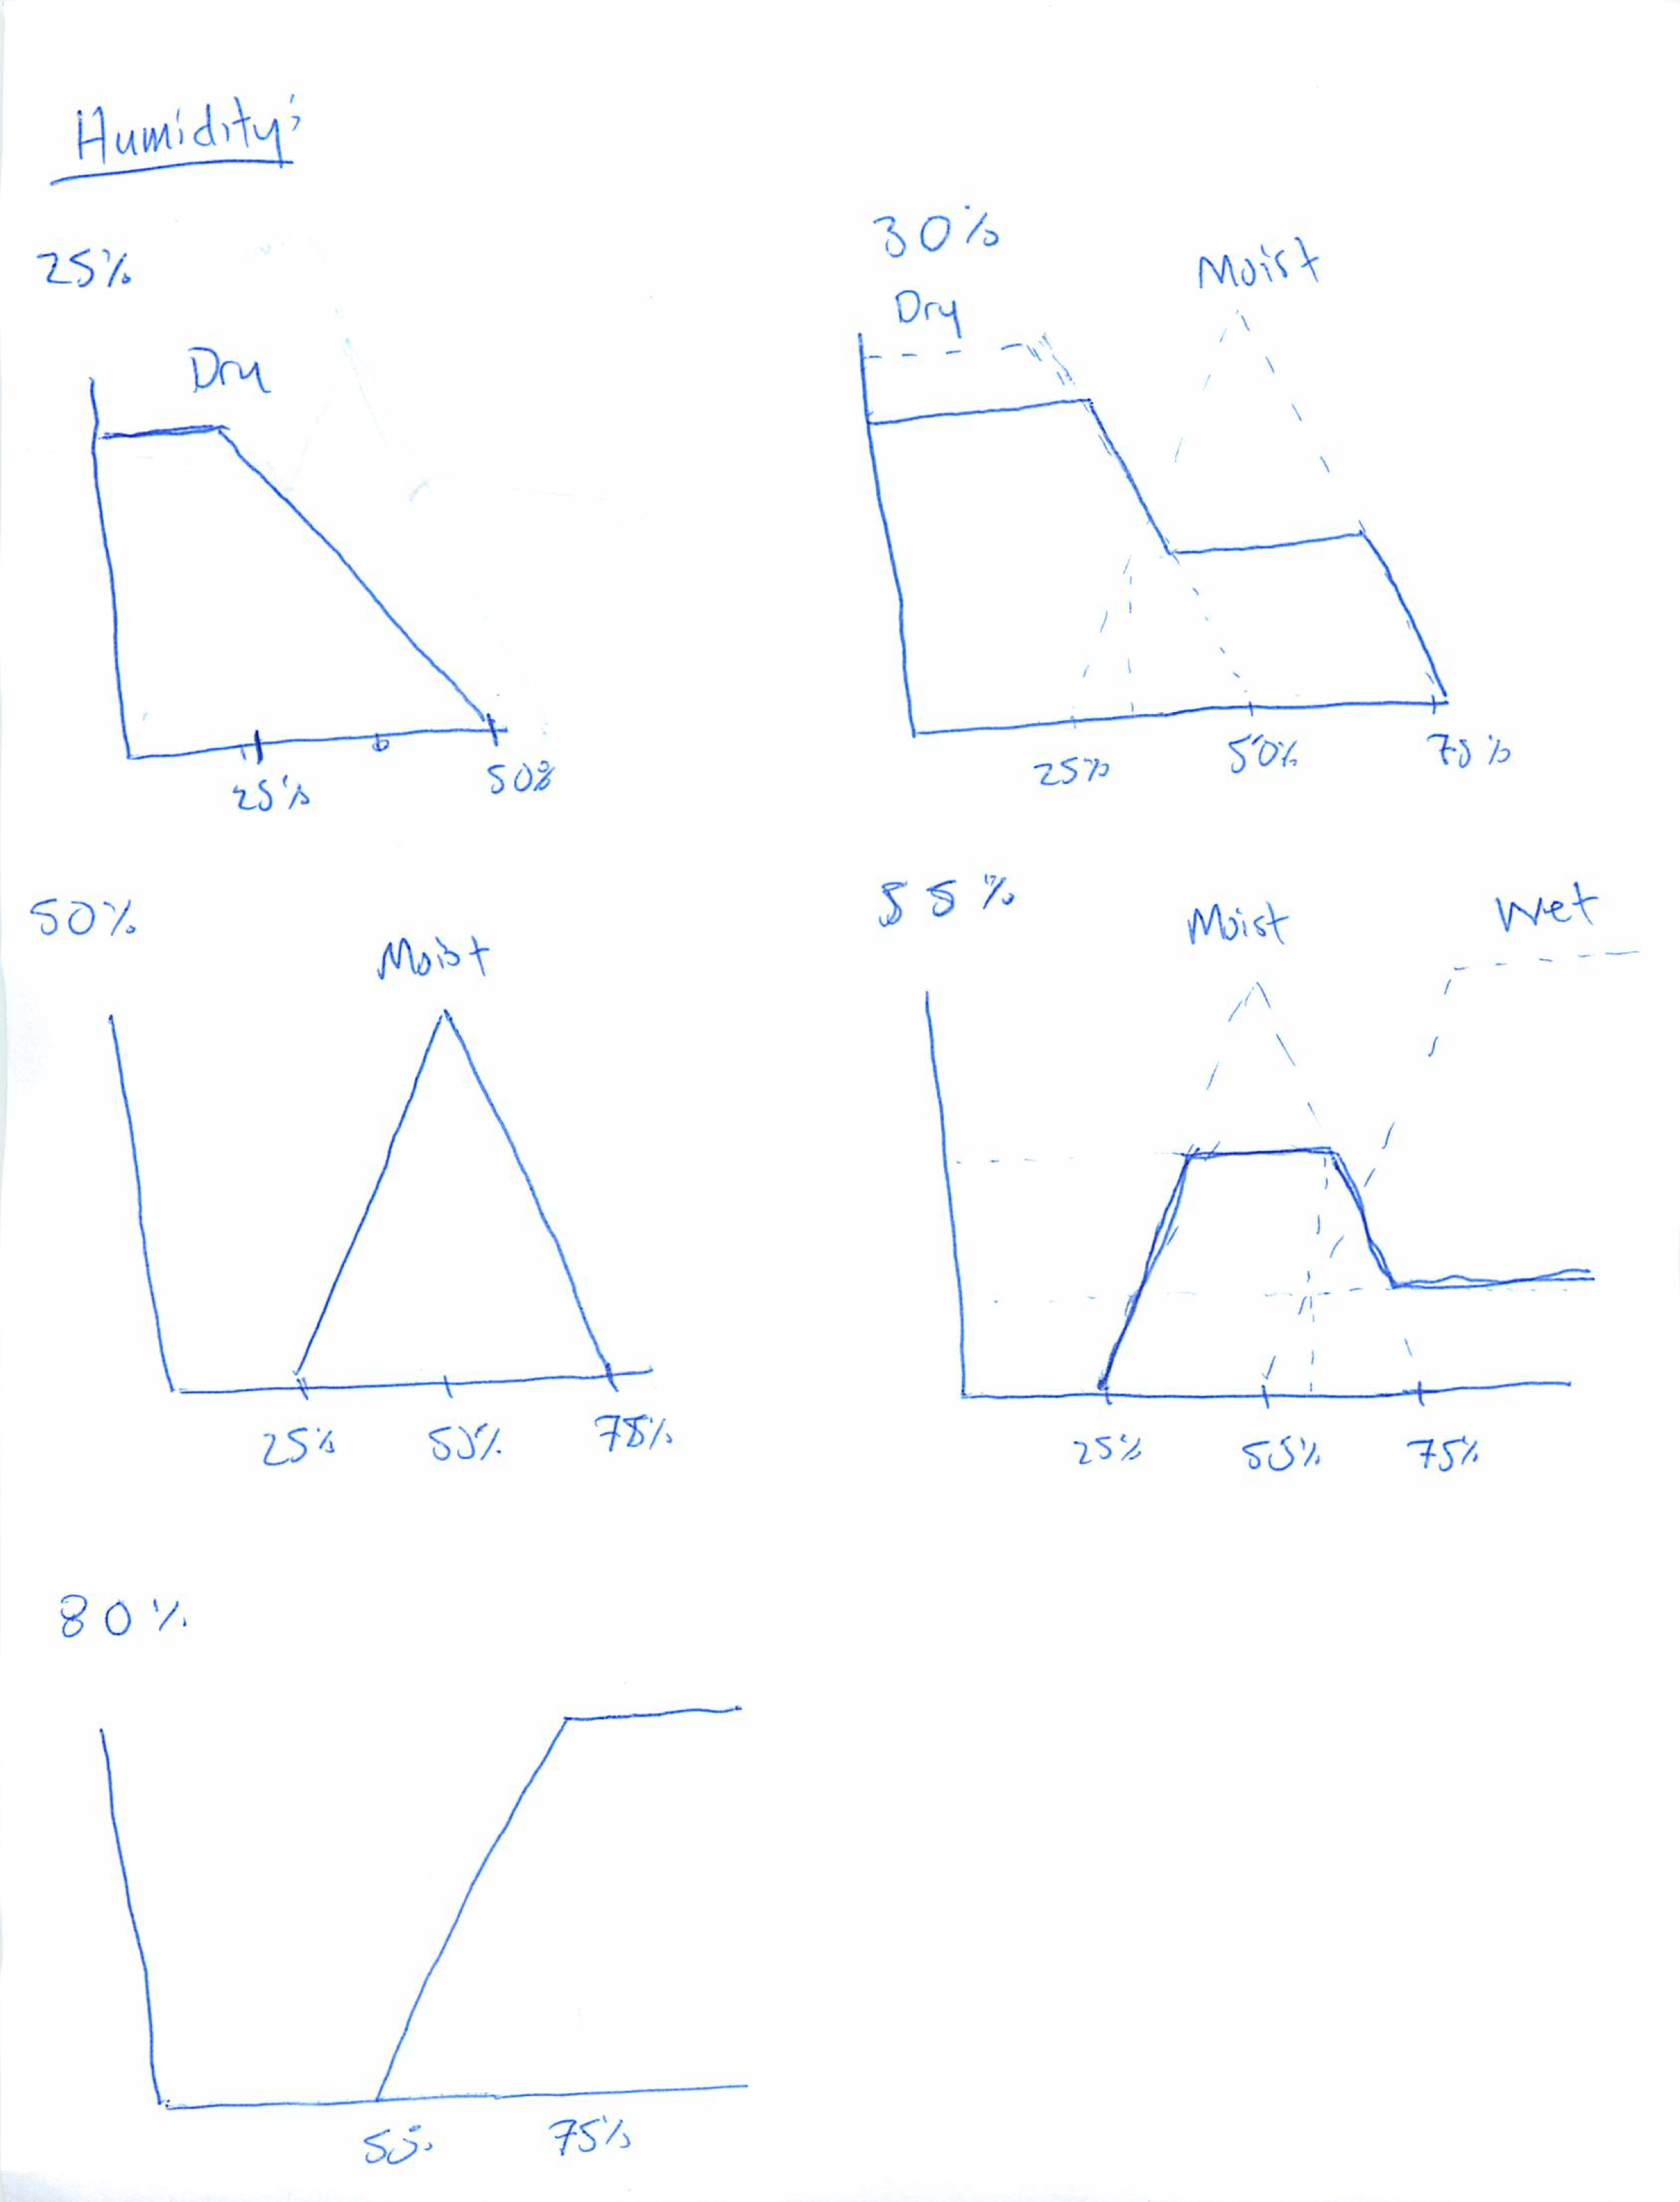
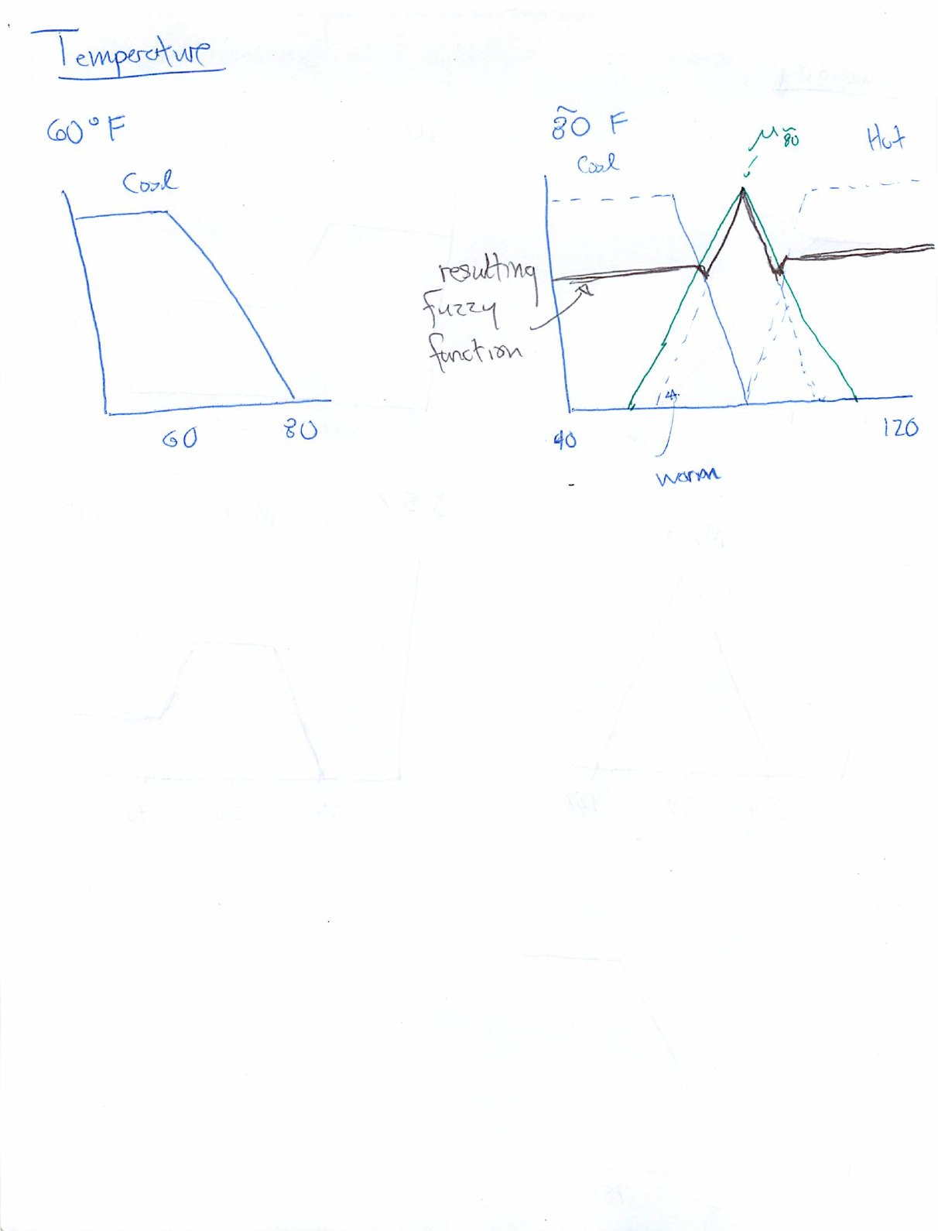
3) Overall, the paper is well written and expresses ideas clearly. In particular, the images presented of the several examples of membership functions, and the images of Bezier curves highlighting how movement of single points significantly affect the overall curve, were rather useful in understanding the concepts presented.
A particular suggestion would be the addition of an appendix, in which the mathematical proofs and details could be placed. This would ease readability of the paper in general, as well as allowing for inclusion of more mathematical detail. I’m not sure of the format required for the journal, so I don’t know if this is even possible. Also, it would improve readability if some short verbal explanations of the algorithms were included either before or after each. This would allow the reader to gain a sufficient understanding at a glance. The algorithms, as listed, do not lack clarity; it simply take some time to parse out the pseudocode format and understand what they are doing.
One possible concern with the method itself is that it still seems to require some expert operator to decide upon the shape of the membership function that best represents the particular phenomenon. I think this issue stems more from the problem of lacking sufficient data to extrapolate a membership function, as it seems likely that construction of a membership function via this method could be accomplished if data were available.

